### **Project 13: Soil Humidity Sensor**

**Description**

This is a simple soil humidity sensor aims to detect the soil humidity. If the soil is in lack of water, the analog value output by the sensor will decrease; otherwise, it will increase. If you use this sensor to make an automatic watering device, it can detect whether your botany is thirsty to prevent it from withering when you go out. Using the sensor with Arduino controller makes your plant more comfortable and your garden smarter. The soil humidity sensor module is not as complicated as you might think, and if you need to detect the soil in your project, it will be your best choice. The sensor is set with two probes inserted into the soil, then with the current go through the soil, the sensor will get resistance value by reading the current changes between the two probes and convert such resistance value into moisture content. The higher moisture (less resistance), the higher conductivity the soil has. Insert it into the soil and then use the AD converter to read it. With the help of this sensor, the plant can remind of you: I need water.

**Specification**

* Power Supply Voltage: 3.3V or 5V
* Working Current: ≤ 20mA
* Sensor type: Analog output
* Interface definition: OUT- signal, GND- GND, VCC- VCC
* Packaging : Electrostatic bag sealing

**Equipment:**

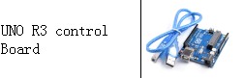

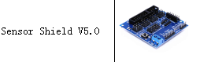

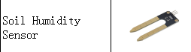

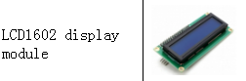

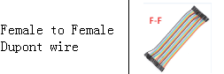

**Connection Diagram:**

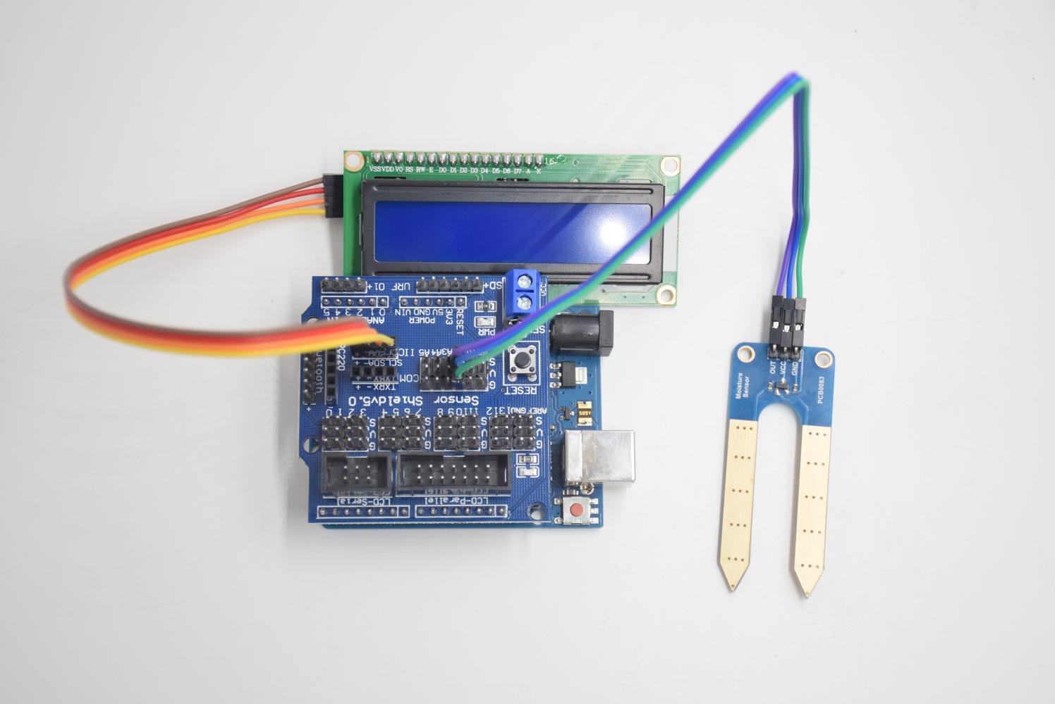

**I2C 1602 display Soil module**

**SCL -- SCL OUT -- A2**

**SDA -- SDA VCC -- 5V**

**- -- GND GND -- GND**

**+ -- 5V**

**Test Code：**

**#include <Wire.h>**

**#include <LiquidCrystal_I2C.h>**

**volatile int value;**

**LiquidCrystal_I2C mylcd (0x27,16,2); // set the LCD address to 0x27 for a16 chars and 2 line display**

**void setup () {**

**Serial.begin (9600); // Set the serial port baud rate to 9600**

**value = 0;**

**mylcd.init ();**

**mylcd.backlight (); // Light up the backlight**

**mylcd.clear (); // Clear the screen**

**Serial.begin (9600); // Set the serial port baud rate to 9600**

**pinMode (A2, INPUT); // Soil sensor is at A2, the mode is input**

**}**

**void loop () {**

**Serial.print ("Soil moisture value:"); // Print the value of soil moisture**

**Serial.print ("");**

**Serial.println (value);**

**delay (500); // Delay 0.5S**

**value = analogRead (A2); // Read the value of the soil sensor**

**if (value <100) // If the value is less than 300**

**{**

**mylcd.clear (); // clear screen**

**mylcd.setCursor (0, 0);**

**mylcd.print ("value:"); //**

**mylcd.setCursor (6, 0);**

**mylcd.print (value);**

**mylcd.setCursor (0, 1);**

**mylcd.print ("dry soil"); // LCD screen print dry soil**

**delay (300); // Delay 0.3S**

**}**

**else if ((value>=100) && (value <= 200)) // If the value is greater than 300 and less than 700**

**{**

**mylcd.clear (); //clear screen**

**mylcd.setCursor (0, 0);**

**mylcd.print ("value:");**

**mylcd.setCursor (6, 0);**

**mylcd.print (value);**

**mylcd.setCursor (0, 1);**

**mylcd.print ("humid soil"); // LCD screen printing humid soil**

**delay (300); // Delay 0.3S**

**} else if (value> 300) // If the value is greater than 700**

**{**

**mylcd.clear ();//clear screen**

**mylcd.setCursor (0, 0);**

**mylcd.print ("value:");**

**mylcd.setCursor (6, 0);**

**mylcd.print (value);**

**mylcd.setCursor (0, 1);**

**mylcd.print ("in water"); /// LCD screen printing in water**

**delay (300); // Delay 0.3S**

**}}**

**Test Result：**

Connect according to wiring diagram, and burn the program and power on. Open the serial monitor and insert the soil humidity sensor into the soil. The greater the humidity is, the bigger the number, in the range of 0-1023. The soil sensor is inserted into the soil and water with different humidity, and the 1602LCD displays the corresponding value.